Project Report: Data Analysis of the Iris Dataset

Date: May 8, 2026
Tools: Jupyter Notebook
Subject: Classification of Iris Flower Species

1. Executive Summary
The purpose of this project was to conduct a comprehensive exploratory data analysis (EDA) on the Iris dataset to identify the physical characteristics that distinguish three flower species: Setosa, Versicolor, and Virginica. Through statistical summaries and visualizations, we determined that petal measurements are the most reliable predictors for species classification, with Iris-Setosa being uniquely identifiable from the other two groups.

2. Data Overview
The dataset consists of 150 observations across 5 primary variables.
- Total Samples: 150
- Features: Sepal Length, Sepal Width, Petal Length, and Petal Width (all in cm).
- Target Classes: 3 (Setosa, Versicolor, Virginica).
- Data Quality: The dataset is perfectly balanced with exactly 50 samples per species. No missing values or significant data entry errors were found.

3. Univariate Analysis (Distribution & Spread)
Using Histograms and Box Plots, we analysed the distribution of each individual trait.
Key Findings:
- Petal Measurements: Petal length and width show a "tri-modal" distribution, meaning there are three distinct peaks corresponding to the three species. This suggests high predictive power.
- Sepal Measurements: Sepal length and width show significant overlap between species, making them less effective as standalone classifiers.
- Outliers: Analysis of box plots revealed a few outliers in Sepal Width for the Setosa species, but these were not significant enough to skew the overall analysis.

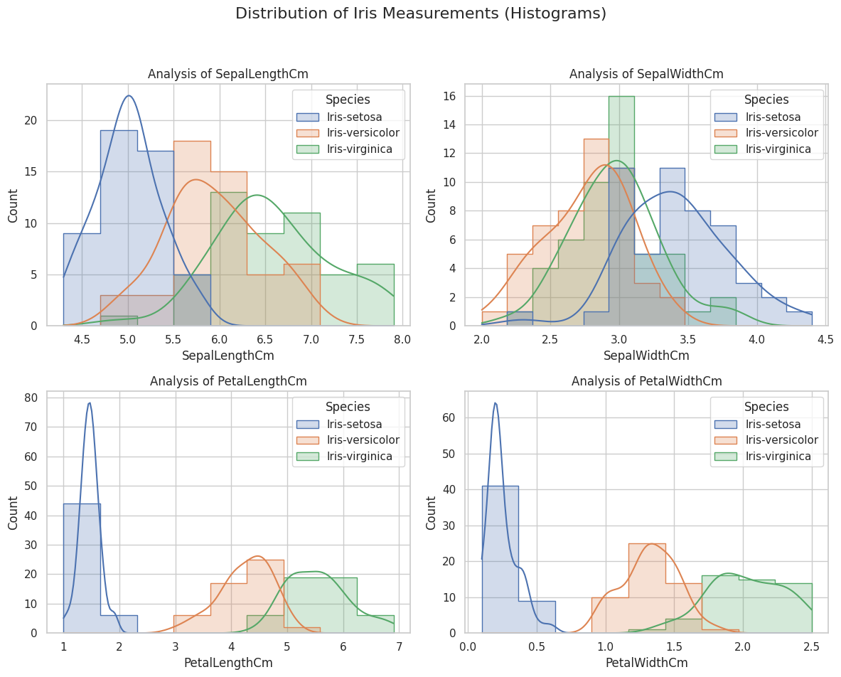
Histogram

Histogram Findings:
- Feature Importance: Petal Length and Petal Width are the best features for separating species. They show distinct "peaks" (clusters) with very little overlap.
- Linear Separability: Iris-Setosa is completely isolated in all plots. Its petal measurements are significantly smaller than the other two, making it linearly separable.
- The Overlap Zone: Iris-Versicolor and Iris-Virginica show significant overlap in Sepal Length and Sepal Width, making these "weak" features for classification.
- Distribution Shape: Most features follow a Normal Distribution (bell curve), though the petal features are Bimodal/Trimodal because the species cluster at different measurement points.

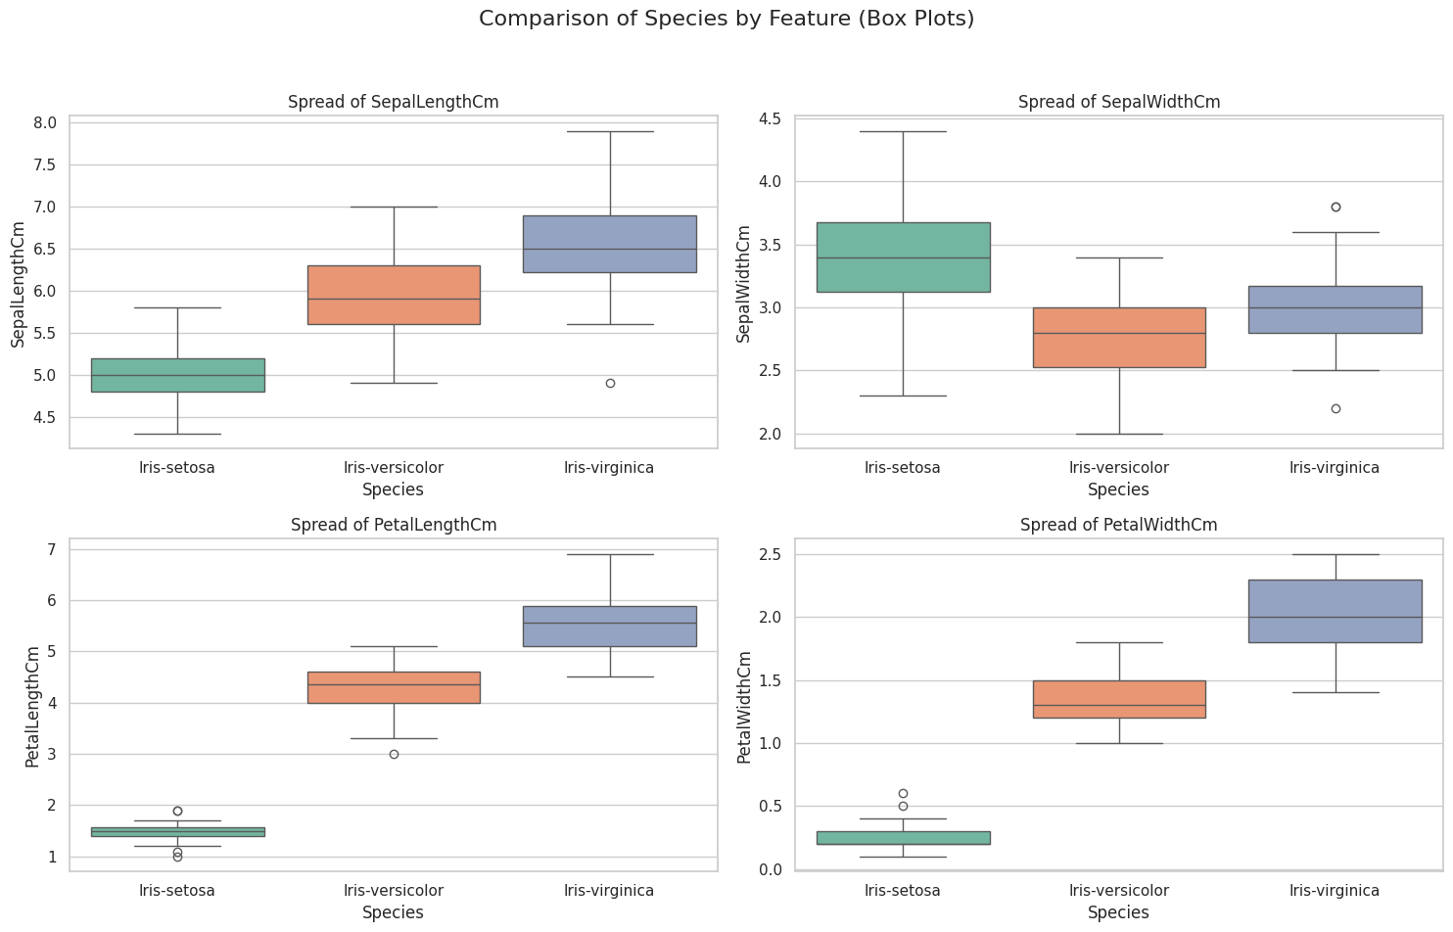
Box Plot

Box Plot Findings:
- Outlier Detection: Iris-Setosa shows a few outliers in Sepal Width. These are rare data points that fall outside the typical range for that species.
- Median & Size: Iris-Virginica consistently has the highest median for almost all measurements, confirming it is the largest species overall.
- Feature Variance (Spread): The "boxes" for Petal Length are very spread apart. This lack of overlap confirms that petal length is the most reliable way to identify a species at a glance.
- Sepal Overlap: The boxes for Sepal Width sit at almost the same horizontal level for all three species, proving that width is a poor differentiator.

4. Multivariate Analysis (Relationships)
By examining how features interact using Pair plots and Correlation Heatmaps, we identified deep patterns in the data.
Key Findings:
- High Correlation: There is an extremely strong positive correlation (0.96) between Petal Length and Petal Width. Effectively, as the petal grows longer, it consistently grows wider.
- Linear Separability: The Pair plot visually confirms that Iris-Setosa forms a cluster that is entirely separate from the other two species. It is "linearly separable," meaning a simple threshold can identify it with 100% accuracy.
- The "Species Gap": While Versicolor and Virginica show some overlap in sepal dimensions, they remain largely distinct when comparing petal sizes.

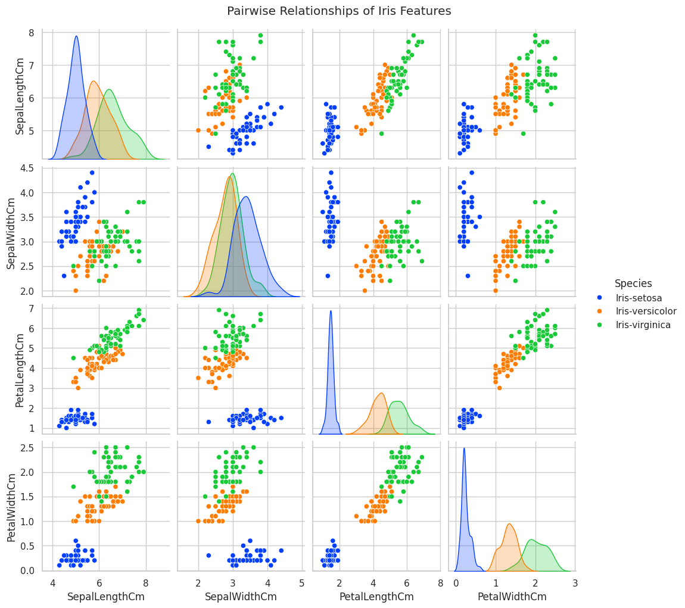
Pair Plot

Histogram Findings:
- Feature Importance: Petal Length and Petal Width are the best features for separating species. They show distinct "peaks" (clusters) with very little overlap.
- Linear Separability: Iris-Setosa is completely isolated in all plots. Its petal measurements are significantly smaller than the other two, making it linearly separable.
- The Overlap Zone: Iris-Versicolor and Iris-Virginica show significant overlap in Sepal Length and Sepal Width, making these "weak" features for classification.
- Distribution Shape: Most features follow a Normal Distribution (bell curve), though the petal features are Bimodal/Trimodal because the species cluster at different measurement points.

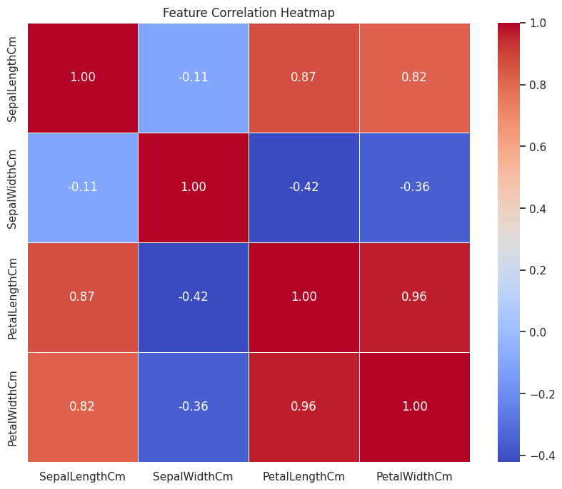
Heat Map

Box Plot Findings:
- Outlier Detection: Iris-Setosa shows a few outliers in Sepal Width. These are rare data points that fall outside the typical range for that species.
- Median & Size: Iris-Virginica consistently has the highest median for almost all measurements, confirming it is the largest species overall.
- Feature Variance (Spread): The "boxes" for Petal Length are very spread apart. This lack of overlap confirms that petal length is the most reliable way to identify a species at a glance.
- Sepal Overlap: The boxes for Sepal Width sit at almost the same horizontal level for all three species, proving that width is a poor differentiator.

5. Final Conclusions & Identification Rules
Based on the evidence, the species can be identified using the following criteria:

Species | Primary Identifier | Typical Petal Length
Iris-Setosa | Smallest petals, isolated cluster | < 2.0 cm
Iris-Versicolor | Medium petals, slight overlap | 3.0 cm – 4.8 cm
Iris-Virginica | Largest petals, high density | > 5.0 cm

